Jessica Noble

ENP 161: Human Factors Product Design

Dan Hannon

13 March 2012

Individual Project Progress Report

iCaddy: Instructional Golf App for iOS

**Project description**

Proposed is a tool for self-instruction, perhaps after one or two sessions with a professional golf instructor. It is an application for the iPad that first allows the user to keep track of the ranges for each of his or her clubs. This app would allow for tracking over time, as well as integration of this data into other aspects of this app. The second major feature of this app is range finding. This activity is completed using the camera on the back of an iPad, and some image processing. The user holds up the iPad to perform the range finding task, and the iPad finds the pin, measures its size to compute the distance, and then suggests a club, using the golfer’s prerecorded ranges. Finally, as the golfer performs the above activities, the app is constantly monitoring performance and providing appropriate tips and suggestions for the golfer. In this way, the app experience is customized to the golfer, and promotes improvement wherever it detects the user may be having trouble.

**Work Breakdown**

Develop Questionnaire:

The next step is to develop a questionnaire with mostly closed questions about my design. The interviews previously performed were mostly open-ended questions, and they helped me hone in on what information I am still lacking before I begin prototyping, as well as enough direction to sketch up the interface for this app. I now want to develop a quick questionnaire and distribute it to at least 20 people to get some quick feedback on my sketches before delving into prototype development. From the interviews, I have developed sketches of how the user interface should look. These will be included in this questionnaire to receive initial user feedback on interface design.

Distribute Questionnaire

I plan on distributing this questionnaire to golfers in my family, and ask them to forward on the link to their golfer friends. I know at least 10 golfers over the age of 50, and if they forward the questionnaire on to their friends, I should hopefully be able to get 20 responses fairly quickly, as my questions will be almost entirely closed response.

Develop Design Requirements

Once I receive feedback from my questionnaire, I can finalize my design requirements. This will be in the form of design specifications for the prototype, based on needs discovered through my literature review, interviews, and questionnaire.

Develop Prototype

I would like to develop my prototype in iOS. This would allow users to experience the full feel of the app, and let them use gestures while testing the app instead of being limited to a mouse. Also, this would allow for user input into the device. The app will of course not be fully functional, but the main user interface components will be implemented to allow for usability testing. I believe I should be able to complete this within the two weeks allotted to this task, and have a working prototype for testing by April 6th.

Develop Usability Testing Procedure

Once I have a functional prototype, I can begin designing the questions and testing procedure for my app. I would like to perform one focus group with family of friends nearby, as well as take an iPad to a driving range or golf instructional facility to get user feedback on usability.

Final Iteration/Modifications

Throughout usability testing, I will make changes to the app based on user feedback before submitting a final design to the client.

Write Report

Currently I have 2 weeks budgeted for writing the report.

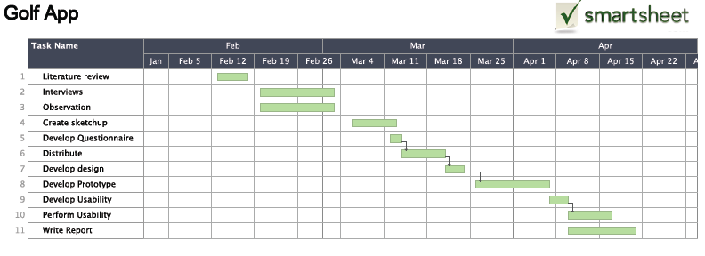

**Summary of Work**

Literature Review

New Golfers:

Golfers, especially men, do not like to take golf lessons. This may be due to embarrassment, or because they believe they should be able to learn on their own. It could be due to the fact that they do not think that the lesson is worth the cost—often people take one lesson expecting a large improvement after, and when this does not occur, they stop taking lessons. One way to combat both of these problems is golf simulators, which are becoming very popular at golf clubs and instructional facilities. An hour in the simulator is half the cost of an hour lesson, and it is a more private experience. [1]

Based on this finding, I decided that a golf app would be a great tool for golfers who do not want to take lessons, but would want an instructional tool for their game. This app, while not providing the level of assistance of an instructor, would provide a private learning experience that is customized to their game.

Golf Apps:

Swing Analyzers

Swing It Series: This family of apps is an instructional tool that allows you to correct your swing. The Swing It app is a $49 that allows you to record yourself hitting a ball, then shows you lines representing the contours of your body, and makes suggestions on how to adjust your swing. The more fully featured app, Swing It Pro, is $149, and is expected to be bought by professional golfers and golf instructors. There is also the free app, that can open Swing It videos and analysis, but cannot analyze the swing itself—this is meant to be used by students of golf instructors to review notes made on their swing during a lesson. [2]

Tiger Woods’ My Swing: Similar to the Swing It series, this app allows you to take video of your swing, and then overlays “Tiger Lines” showing where the lines of your body are, where they should be, and how to correct it. This app is $9.99. [3]

Based on the above research, I decided to drop the swing analysis feature on my app. It would include a fair amount of image processing to implement, and there are apps on the market that can already perform this function better than I would be able to accomplish.

Range Finders:

Golf range finders generally fall into 3 categories: laser range finders, GPS range finders, and optical range finders. Laser range finders are generally the most accurate, but they are very expensive. GPS range finders require that you download the course information ahead of time (if the GPS device’s database has course information for the course). Optical range finders are the cheapest, and least accurate. They cost about 10% of the other types of apps, contain no electronic components, and are very easy to use. This device is what I based my range finder function on.

**Interviews**

Below are the interview questions I delivered to my father, with his responses transcribed from an audio recording. I also gave this interview to my grandfather, but I have not transcribed the responses yet. My father is 49, and my grandfather his 75. They both live in Orange County, CA and have been golfing since they were children.

*Did you take golf lessons when you first learned how to golf?*

I've never had a lesson. When I was learning to golf, they were too expensive.

*What tools did you use when you were first starting out?*

I hit a lot of whiffle balls in the backyard when I was little. Papa Gary and Papa Roger taught me how to play.

*How do you remember your ranges for your clubs?*

I committed them to memory. Like a lot of people, I only hit the clubs I hit well. I use the clubs I like, even if there's another club I probably should be using, I kind of understand how it all works for my own clubs.

*Do you use a range finder while on the course?*

Dad: I’ve used the GPS in Hawaii. It’s great when you’re there, but then you come back to Prado or Anaheim Hills and they don’t have that.

*Do you have a smart phone?*

I do

*I'm creating an instructional golf app for a class.  This app has many parts:*

*First, you take this app to the driving range and record your ranges for your clubs.*

*Then, while you're golfing, you use the app as a range finder by holding the iPhone or iPad toward the green.  Similar to an optical range finder, the device uses the camera to measure the height of the pin in the image, and determine how far away the hole is.*

*The device also lets you keep score during the game.*

*Finally, the app combines your score and the measured ranges for your strokes to provide tips customized to your game.*

*Would you be interested in an app like this?*

That's amazing. Can you actually do that? Absolutely. That is mind numbingly awesome. I also like that, you know, they move things around because parts of the green are under repair, and the GPS doesn't work on that anymore, but you know, yours is accurate every time.

*Are there any features you would expect to be included in such an app?*

Wind. Direction. If you could figure out how fast the wind is blowing--what speed it is. Then it could calculate, if the wind's blowing 20 miles to the left, it could give you a picture of how far you'd have to hit the ball to the right to land on the green. Those are the kinds of things that are really difficult to do, to get out there on a windy day when you’re just starting out.

*Is there anything that you do not like or think should be changed for this to be a successful product?*

If it's accurate, you know, that's all anyone really cares about. If it worked perfectly, you could sell it for $99 or $199. Especially if you get it in the golf magazines, or run an infomercial on the app.

**Sketch ups:**

I have begun sketching the interface for this app. I did this first with a pencil and notebook paper, and am working on making these sketches cleaner to include in my questionnaire when it is distributed. I will include the nicer sketches in the below description where I have them currently available.

The main navigation tool for this app is the strip of navigation buttons at the bottom of every view. These buttons are always visible to allow the user to quickly navigate the app. This layout splits the app into 4 components:

*Score Card*: This section of the app allows the user to enter in new course information (i.e. the par for each hole in a new course), keep score, take notes on various holes for next time. The app keeps track of previous scores for each hole, and the user can access this in the “Notes” section of the scorecard.

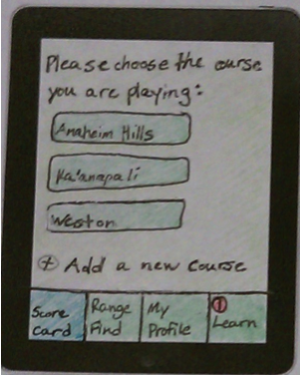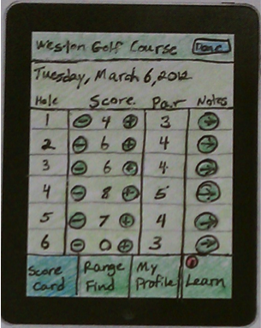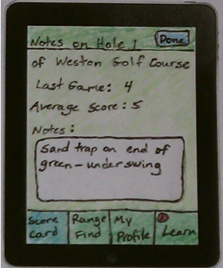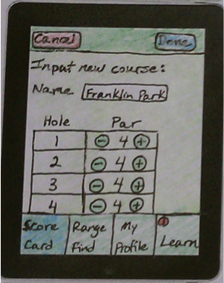

*Range Find*: This section is the range finding tool of the app. The user points the camera at the flag and is prompted “Please touch the pin.” When the device detects a touch on the streaming image, it saves one still image and performs a line detection algorithm near the user’s touch coordinates to find the vertical line of the flagstaff. It then overlays a rectangle so the user can see where the app detects the pin, and can verify that this is correct. If it is, the app calculates the distance of the pin, and suggests a club based on that distance. There will also be options for telling the app that you are going uphill or downhill, and the app will “add 10 yards” or “subtract 10 yards” accordingly, as is a common adjustment when golfing.

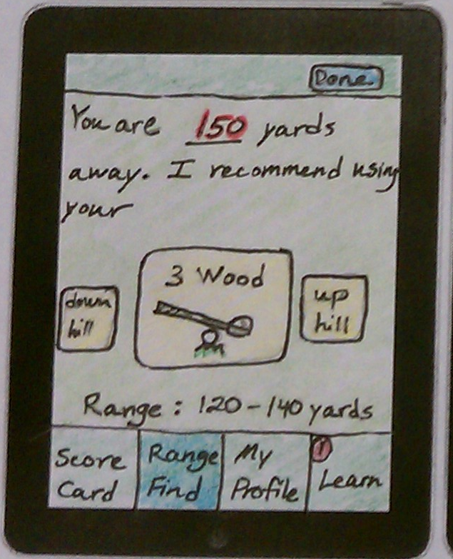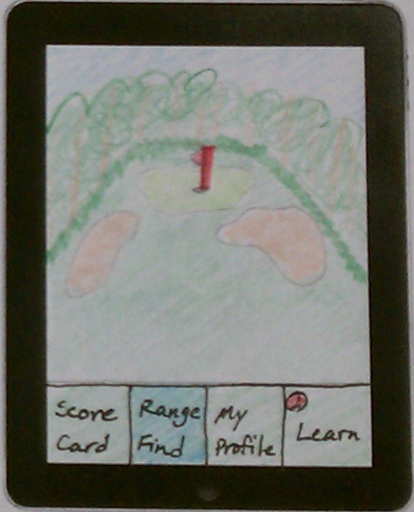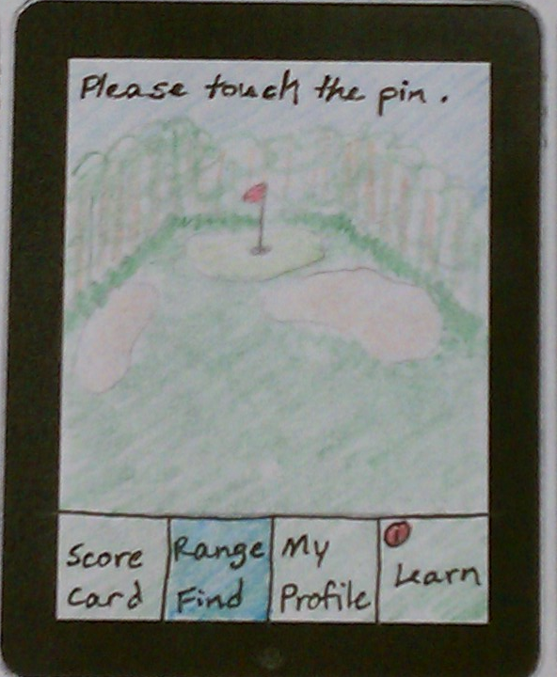

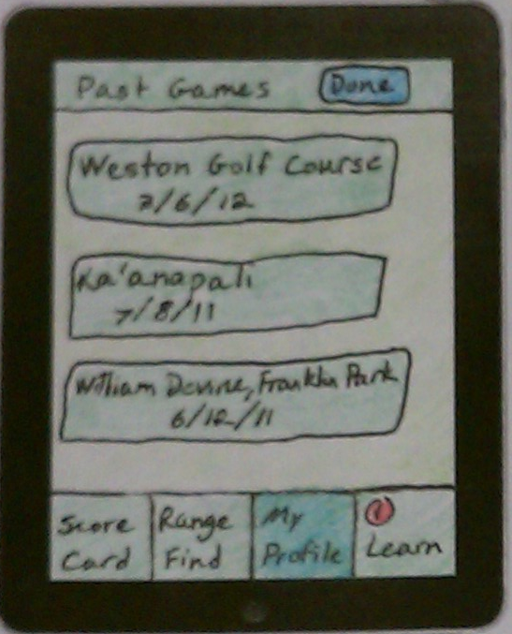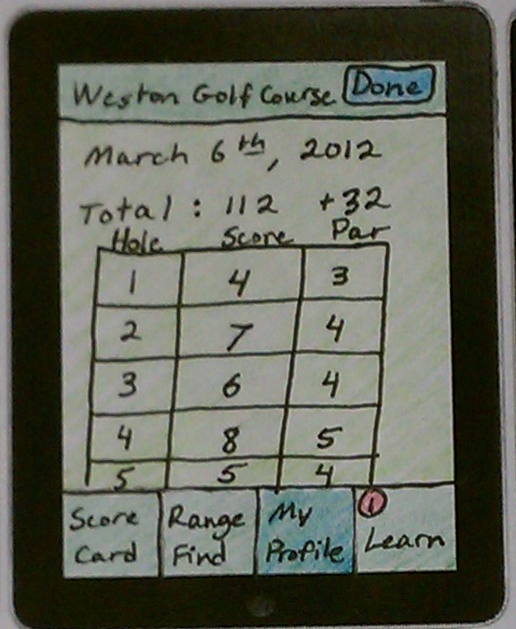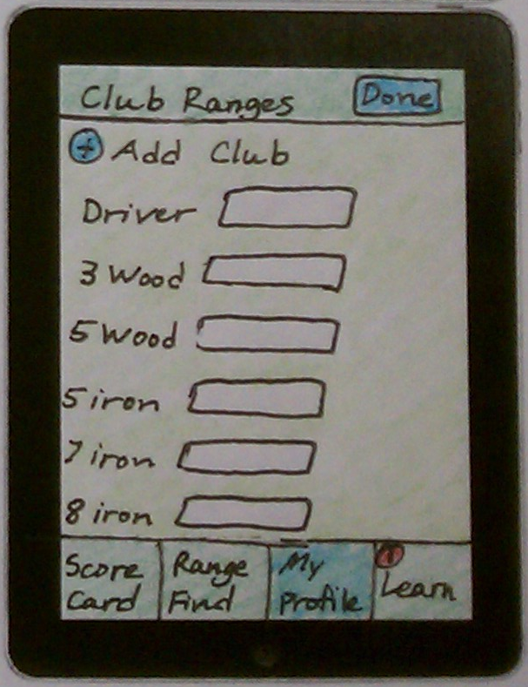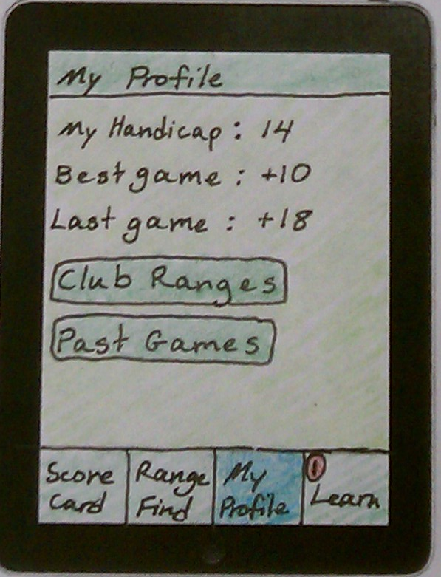*My Profile*: This is where the user can look up his stats (handicap, previous scores, etc.), as well as input ranges for his or her clubs.

*Learn*: This section will be the main instructional tool of the app. Based on scores, measured distances hit, etc, the app will bring up suggested tips and tutorials that are customized to the golfer’s game. In addition, this section will have a search feature so the golfer can find other help pages as well.

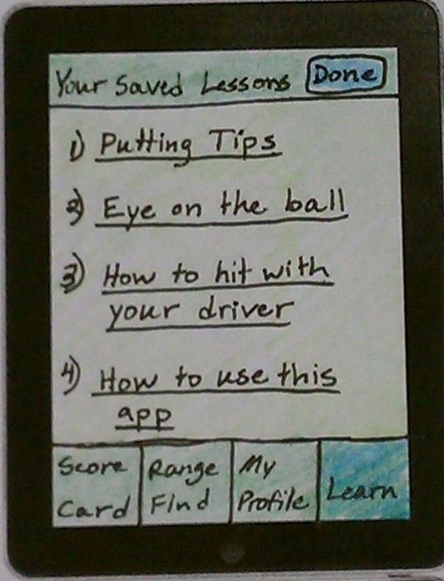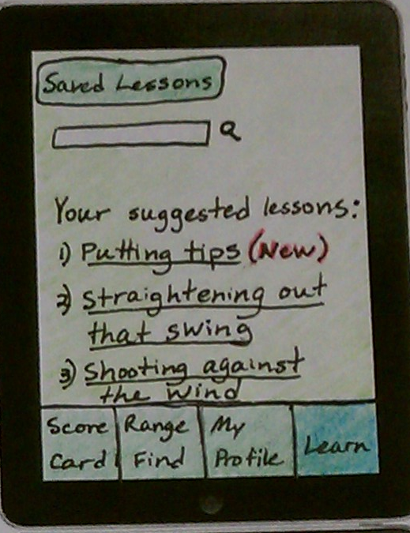

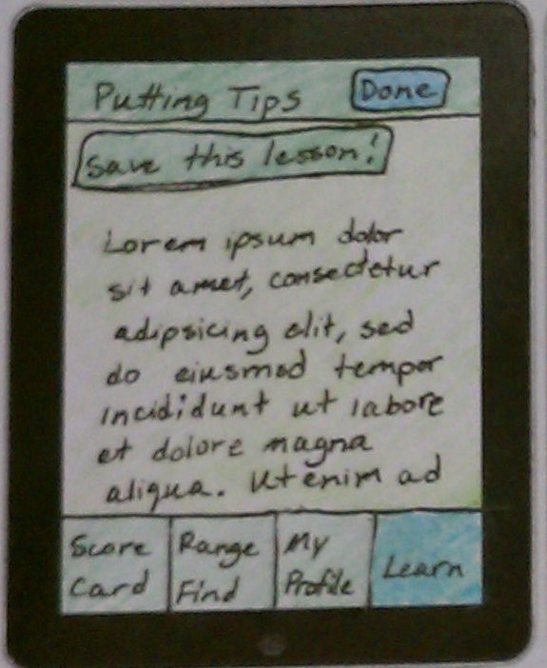

**Risk Management:**

There are two areas where I can foresee that there may be delays in the schedule. First, I am going to Kansas for a bridal shower on March 23rd. This is right in the middle of my “Develop Design Requirements” phase, which is on the critical path and must be completed before developing a prototype. My productivity that weekend will depend on how well I can work on the plane and how much downtime I will have before and after the shower. The other high-risk part of my project schedule is near the end of the semester. As many projects and finals are due at the end of April, it is unknown how much time I will have at the end of the semester to devote to each. To combat both of these risks, I created my schedule to allow for a 10-day buffer between the final due date and when I anticipate finishing the project. That way, schedules can shift without too much worry, and I will have a good amount of time to finish analyzing usability data and write the report.

**References**:

[1] Pennington, Bill. "How to take lessons in the winter (or in secret)."New York Times 22 Aug. 2011: D6(L). Academic OneFile. Web. 24 Feb. 2012.

[2] Apple App Store.

[3] Tedeschi, Bob. "To Improve Your Swing: Bend Your Knees and Find a Good App." New York Times 5 May 2011: B8(L). Academic OneFile. Web. 28 Feb. 2012.